
PUCIT
Punjab University College of Information Technology

Group members:

Bilal Mubarak BSEF17M056
Maham Mubashir BSEF17M008
Anzala Mohsan BSEF17M018
Mubarra Naz BSEF14M031

Supervisor: Ma’am Madiha Khalid

Lahore Tour Guide
First Deliverable

Table of Contents

Lahore Tour Guide Deliverable 1 3
1 Introduction 3
1.1 Project/Product Feasibility Report 3
1.1.1 Technical Feasibility 3
1.1.2 Operational Feasibility 3
1.1.3 Economic Feasibility 3
1.1.4 Schedule Feasibility 3
1.1.5 Specification Feasibility 3
1.1.6 Information Feasibility 4
1.1.7 Motivational Feasibility 4
1.1.8 Legal & Ethical Feasibility 4
1.2 Project/Product Scope 4
1.3 Project/Product Costing 4
1.3.1 Project Cost Estimation By Function Point Analysis 4
1.4 CPM - Critical Path Method 7
1.5 Gantt chart 9
1.6 Introduction to Team member and their skill set 11
1.7 Tools and Technology with reasoning 12
1.8 Vision Document 12
1.8.1 Introduction 13
1.8.2 Existing System Business Organization 13
1.8.3 Project Overview 13
1.8.4 Scope of the System 13
1.8.5 Summary of Requirements:(Initial Requirements) 14
1.8.6 Identifying External Entities 15
1.8.7 Context Level Data Flow Diagram 16
1.8.8 Capture "shall" Statements and External Entities 17
1.8.9 Allocate Requirements 18
1.8.10 Priorities Requirements 19
1.8.11 Requirements Traceability Matrix 20
1.9 High Level Usecase Diagram 21
1.9 Risk List 21

1 Introduction

1.1 Project/Product Feasibility Report

1.1.1 Technical Feasibility
Our project is technically very feasible because all the main technologies and tools that are associated with the project are freely available and the technical skills required are manageable. The software development team ascertained the technical feasibility of the project and concluded that the project can be undertaken with available technology and resources. Although implementation phase might require hardware additions (mac OS for iOS users) but currently the project is technically feasible and should proceed further.

1.1.2 Operational Feasibility
Our team will go to utilize a neighborly interface that will be adaptable to comprehend and simple to utilize. Smartphone, PC or a desktop computer and a good internet connection are required for its later use by the users. Application is free to use as a tour guide for Lahore City. But if users want to book a place they have to register and login first.

1.1.3 Economic Feasibility
The project is economically feasible as it requires a computer or smartphone (for a hybrid
application) that is available to everyone nowadays. It is not too much expensive because we are using Django REST API which is a free and open source web application framework written in Python.
Acquisition costs (one time)
None
Maintenance and operation costs (ongoing)
Very little.
Benefit Estimates:
None

1.1.4 Schedule Feasibility
The total time to complete this project is approximately 6-7 months. We have divided the project timeline into different sprints. Tasks are divided and given to each member of the group, and they are accountable for completing the task before the given deadline. The scope has been designed so that it can be managed by the team. And since it has a great value in our degree, we are giving it first priority.

1.1.5 Specification Feasibility
Time will be feasible in term of specifications. These requirements are clearly defined.
Following are the main requirements of the system:
- Friendly user interface that users find ease to use this application.
- Users can book a room in minutes by just tapping a button.
- Travelers/tourists can find all nearest places, find all the possible routes to the nearest destinations and get authentic navigations.
- To provide real time availability and guidance of points of interest of user.

1.1.6 Information Feasibility
We have much information about this project as the idea of this project went through the great research. The key focus given is to give user a friendly application for tour guide and booking. The speed and accuracy will be maintained in proper way. Using React Native, Python, Django REST and SQLite, the software can be developed in a neat and simple manner.

1.1.7 Motivational Feasibility
This venture has high motivational consequences for our group. The team is devoted and roused to investigate new skylines and get new abilities. The team is curious about this project and has enough skills to try to do this project. The team’s motivation behind the event of project is to provide a good tour guidance.

1.1.8 Legal & Ethical Feasibility
This project will support legally and ethically all users. This system will not leak out any user credentials. We will protect the private information provided by the users.

1.2 Project/Product Scope
We are looking forward to build a cross platform android and iOS application along with a website platform allowing users of every type to access the platform easily. The application shall provide important details along with contact details for each and every significant place in Lahore. The app shall facilitate users by providing a user-friendly interface making user experience go beyond excellent. The app shall offer absolute navigation facility to every pinpoint. For this purpose, Google Maps shall be used in the system. Moreover, the system shall facilitate landlords by allowing them to post their residential adds that they want to rent. This shall increase revenue for landlords. On the other hand, the app shall permit travelers looking for a place to stay to contact the landlords and book apartments via PayPal. This shall remove the barriers of communication we get while traveling to new places and looking for a perfect residence suiting our budget and type.

1.3 Project/Product Costing

1.3.1 Project Cost Estimation by Function Point Analysis

External inputs
An elementary process processing data from outside the application boundary.
- Registration screen
- User registration data from API.
- Login screen.
- Getting current location of the user.
- Getting advertisement posting data from user.
- Getting reviews data from user.
- Data validation from database (login and signup)
- Getting list of areas of Lahore from database.
- Conversation messages in database.

External outputs:
An elementary process sending data or control information outside the application boundary.
- Registration data to database.
- Login data to database.
- Advertisement data to database.
- Reviews data to database.
- Show advertisements to users.
- Show information of hotels and restaurants to users.
- Show directions to users.
- Conversation messages to database.
- Location search by Google API from local db.

External Interfaces
Shared databases and routines from external applications
- Google Map APIs
- Google signup APIs

External Inquiries
An elementary process that sends data or control information outside the application boundary as interrupts and prompts (or event responders).
- Area selection list for looking into a particular area and all the destinations within that area.
- Dropdown list of the categorized destinations all over the city or at a particular area.
- Directing a specific destination using Google Maps
- Providing message option and opening chat tabs for conversations.
- Locating data of hotels or restaurants upon user’s choice.

Internal files
Relational data stored and maintained within the application boundary (relational databases, flat files/directories).
- User table
- Areas table
- Conversation table
- Advertisement table

No. of inputs:9
No. of outputs:9
No. of inquiries:5
No. of files:4
No. of external interfaces:2

Information domain value | Simple | Average | complex | count | FP count
No. of inputs: | 3 x 3 | 5x4 | 1x6 | 9 | 35
No. of outputs: | 5x4 | 2x5 | 2x7 | 9 | 44
No. of inquiries: | 3x3 | 1x4 | 1x6 | 5 | 19
No. of files: | 1x7 | 2x10 | 1x15 | 4 | 42
No. of external interfaces: | 1x5 | 1x7 | 0x10 | 2 | 12

Count total=152

Data communication | 4
Data distributed processing | 0
Performance | 5
Heavily used configuration | 4
Transaction rate | 3
Online data entry | 2
End user efficiency | 5
On-line update | 4
Complex processing | 3
Reusability | 5
Installation ease | 5
Operational ease | 4
Multiple Sites | 0
Facilitate Change | 4
Total Fi | 48

Calculate Function Point:
FP est.= Count Total * [0.65 + 0.01* (Fi)]
=152 * 1.13
=171.76 p-m
For our project:
Productivity=260 LOC/p-m
Labor Rate=Rs 50,000 per p-m
For 6 months=50,000 * 6
Total Labor Rate = Rs. 300,000 per person
Cost per FP= Cost/FP=Labor Rate/Productivity
=300,000/260
=Rs. 1,153.85 per p-m
=Rs. 1,154 per p-m
Total Project Cost= FP est. * (Cost/FP)
=171.76*1,154
=Rs. 198,211.04
=Rs. 198,211
Effort=Total cost/Labor rate per p-m
=198,211/50,000
=3.96 p-m
=4 p-m

1.4 CPM - Critical Path Method

Activity Sequence and Completion Time
Activity | Activity Name | Immediate predecessor | Duration(days)
A | Concept | None | 10
B | Requirement Gathering | A | 13
C | Cost Analysis | B | 2
D | Context Level Modelling | B | 2
E | Modelling | D, B | 12
F | Explore Tools and Technologies | B | 23
G | Design Mockups | F | 8
H | Login/Signup Module | G | 10
I | Destination Management Module | G | 30
J | Stay management Module | G | 15
K | Integration | H, I, J | 17
L | Training | K | 9
M | Documentation | K | 19
N | Deployment | C, E, L, M | 12

Network Diagram
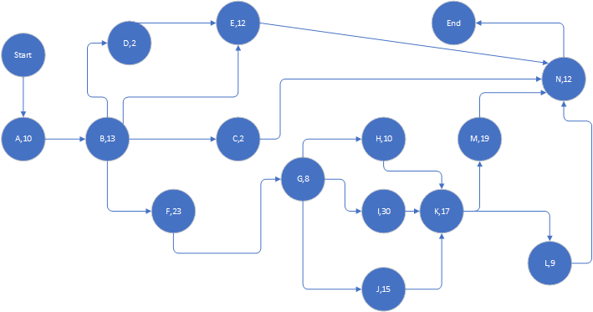

Identify the Critical Path
Activity | Duration(days) | ES | EF | LS | LF | TS | FS
A | 10 | 0 | 10 | 0 | 10 | 0 | 0
B | 13 | 10 | 23 | 10 | 23 | 0 | 0
C | 2 | 23 | 25 | 120 | 122 | 97 | 97
D | 2 | 23 | 25 | 108 | 110 | 85 | 0
E | 12 | 25 | 37 | 110 | 122 | 85 | 85
F | 23 | 23 | 46 | 23 | 46 | 0 | 0
G | 8 | 46 | 54 | 46 | 54 | 0 | 0
H | 10 | 54 | 64 | 74 | 84 | 20 | 20
I | 30 | 54 | 84 | 54 | 84 | 0 | 0
J | 15 | 54 | 69 | 69 | 84 | 15 | 15
K | 17 | 84 | 101 | 84 | 101 | 0 | 0
L | 9 | 101 | 110 | 101 | 110 | 0 | 0
M | 19 | 101 | 120 | 103 | 122 | 2 | 2
N | 12 | 110 | 122 | 110 | 122 | 0 | 0

Critical Path:
A→B→F→G→I→K→L→N

1.5 Gantt chart 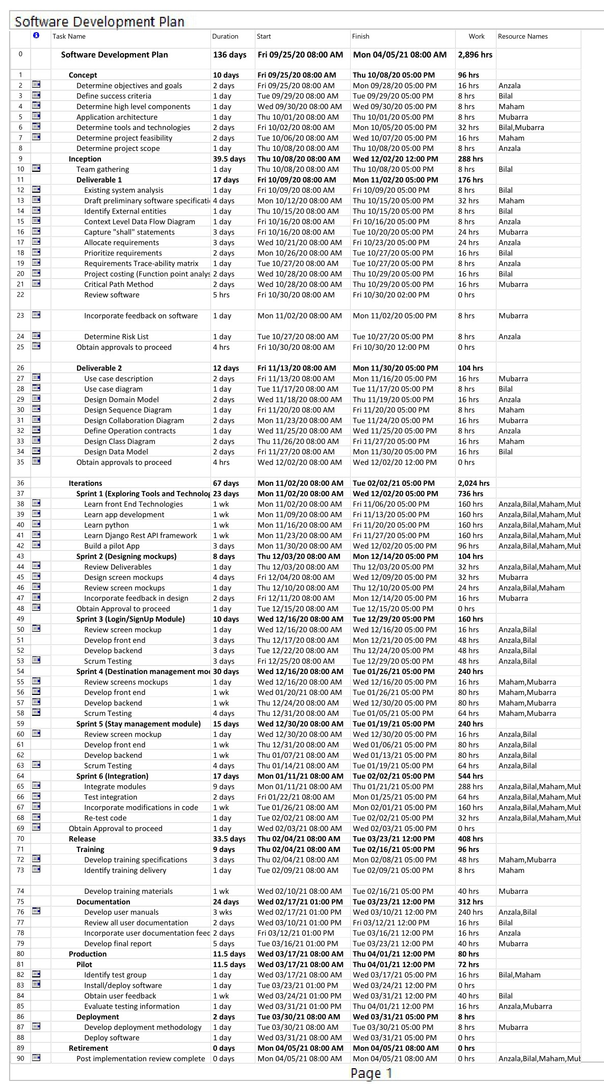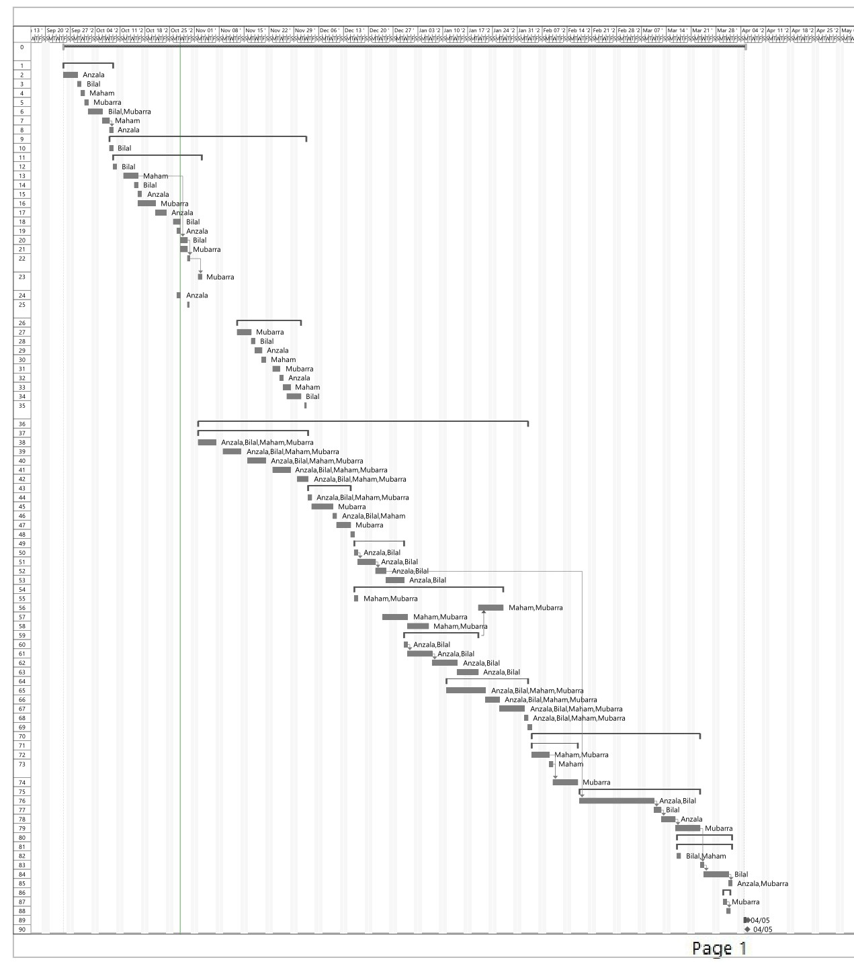

1.6 Introduction to Team member and their skill set
Team member are listed below:

1.6.1 Bilal Mubarak (Team Leader)
His technical skills related to this project include
- C#, JAVA, PYTHON, C++, React Native
- MVC, Django REST API framework
- Web Scraping and backend development
Apart from this he has leadership skills and have already led many term projects. He will be working on development, requirement engineering, testing and designing, managing the project at his best

1.6.2 Maham Mubashir (Team Member)
Her technical skills related to this project include
- C++, Java, PYTHON, C#, PHP, React Native.
- Django REST API framework, MVC, web development
- Requirement engineering
She has good analytic skills. She will be working on development, requirement engineering and designing. she has convincing powers. She will be working on development part.

1.6.3 Anzala Mohsan (Team Member)
Her technical skills related to this project include
- Java, PYTHON, C#, PHP, Angular JS, React Native
- MVC, Django REST API framework
- Analysis and Requirement Engineering
She has good analytic and testing skills. She will be working on development, requirement engineering, testing and designing.

1.6.4 Mubarra Naz (Team Member)
Her technical skills related to this project include
- C/C++, Java, C#, PYTHON, PHP, React Native
- Django REST API framework, Android Development
- Graphic Designing
She has good designing skills. She will make sure that user will have good experience using this Application. She will be working on design and development part.

1.7 Tools and Technology with reasoning
Tools and Technologies | Reasoning
MS word | For documentation, Microsoft Word is a very efficient and reliable word processor. We’ll be using this tool for our documentation purposes.
MS Visio | We will be using these for creating UML and other application diagrams.
MS Project | For Gantt Chart. It’s the best tool being used in the industry for project management plans and for work breakdown structure (WBS) for our project deliverables.
React Native | For front End development. It is an open-source, cross platform framework. The core is JavaScript and is easy to learn and use.
Python | Python is a dynamic, high level, free open source and interpreted programming language. It’s already well recognized as a very universal, versatile, stable, and easy to learn programming language. We are using python to make our web based application secure and also for rapid development.
Django  REST framework | Django is a framework provided by Python. It is a free and open source and also encourages rapid development. We use Django in our project as it follows MTV (Model, Template, View) design pattern, so we can split our code into different modules. We also use Django to build our application backend part.
Pycharm | Pycharm is an IDE for python programming. We are using it because it helps us to edit and improve code without putting extra time and effort. It also provides built in database facility so we don’t need to install any other database server.
SQL Lite | Database. It requires no maintenance or configuration. It is cross-platform, high on performance, reverse compatible, lightweight and portable. And to fulfill our need of storing, processing and securing our database we will be using SQLite for our project. It provides a complete control and fast transaction of data on demand
Agile Development | Discovering requirements and developing solutions with collaborative effort of self-organizing, early and predictable delivery and transparency. SCRUM is used which is an agile framework for sustaining the product.It will help in team work together

1.8 Vision Document

1.8.1 Introduction
The application is made to create a network, connecting paying guests with landlords enhancing affective communication. In order to develop a website and a mobile application where users can book a room in minutes by just tapping a button. We will provide a platform where travelers/tourists can find all nearest places, find all the possible routes to the nearest destinations and get authentic navigations. And to promote tourism by making tourism concise and easier to access.

1.8.2 Existing System Business Organization
Currently there are no applications that have been built on “Lahore Tour Guide” idea. However, there is another app which is used as tour guide and separate hotels website for room allocation and no such application exist for paying guest. But this app will combine all three works for user. This is the uniqueness of our application. We will also provide users with the facility to add advertisement of their place at this platform.

1.8.3 Project Overview
Our aim is to create a user-friendly application for guiding the tourists and paying guests to learn best about the Lahore city. Our application will define, describe and direct the users to specific locations. For this purpose, we are going to integrate google maps in our application. Moreover, our system will allow the renters to quickly contact landlords. The renters can select a certain area and see the list of rooms available, public reviews and feedbacks and then book a room easily via online payment or on-site payment. By default, the app will locate the current location of the user and show the nearby areas and points of interest. These locations will be divided in several categories to help user make custom search easier.
The users can change the location and find the areas and places anywhere in the city.
On the other hand, landlords can have their profiles and post advertisements for the availability of the rooms and apartments. The renters can either book rooms in hotels or can find a room to stay as paying guest.

1.8.4 Scope of the System
The scope of the project can be divided into following phases:

1.8.4.1 Concept
Defining project goal and objectives along with the success criteria of the project. Gathering high level components and application architecture in order to estimate the extent of the system and the target audience.

1.8.4.2 Inception
The phase includes planning and requirement gathering. Moreover, it includes modelling the requirements to get accurate picture of the working system.
The scope of this document is limited to first half of this phase.

1.8.4.3 Iterations
This is the development phase of the system. At the end of each sprint, we get a working module as an output and integrating them all together in the last sprint to get a complete and correct working system.
The phase results in following working business areas
- Account maintenance
- Location guidance
- Location detailing
- Easier contact access
- Conversation facility with landlords.

1.8.4.4 Release
Phase II involves complete automation of the application. The phase involves the final documenting procedures for training the staff on how to manage and use the software along with the development of user manuals.

1.8.4.3 Production
Phase III covers a complete solution for “Lahore Tour Guide”. The phase includes pilot and deployment procedures. The application is made open to the end users publicly.

1.8.5 Summary of Requirements:(Initial Requirements)
The purposed system must fulfill following requirements as follow:

1.8.5.1 GPRS Connectivity
GPS connection is necessary for navigation and location finding.

1.8.5.2 User Registration and Authentication
For advertisements and reviews user authentication is necessary.

1.8.5.3 Categorizing destinations
Destinations shall be categorized so that users can easily access similar locations at once

1.8.5.4 Destination Guidance
Everything that a user needs to know about a location should be all together. So that user does not have to search here and there for details.
Moreover, the ser should get complete navigation guidance for the destination.

1.8.5.5 Review addition/update
User should be able to add their reviews to not only amusement locations but also to the adds posted. So, others can get a public opinion regarding destinations.

1.8.5.6 Add posting
Users should be allowed to post adds for their rental apartments. They should be able to add details and pictures of place.

1.8.5.7 Add maintenance
The user doesn’t have to post the adds for the same room again and again. He can just manage the availability for the room and the add will go public again.

1.8.5.7 Chat with Landlords
People looking for rental apartments or rooms shall be allowed to have chat with landlords regarding their stay and apartment.

1.8.6 Identifying External Entities or Actors

1.8.6.1 Over Specify Entities from Abstract
On the basis of the Abstract, one might identify the following entities from the Lahore Tour Guide case study.
- Toursit/traveler
- Buyer
- Seller
- Notification
- Advertisement
- Post
- Review
- Account
- Credit Card
- Google maps
- Signup APIs
- Login APIs
- Google maps APIs

1.8.6.2 Perform Refinement
We found the following entities more related to our Business Logic;
- Traveler
- Owner of the rooms
- Signup and Login APIs
- Google maps APIs
- Google maps

1.8.7 Context Level Data Flow Diagram
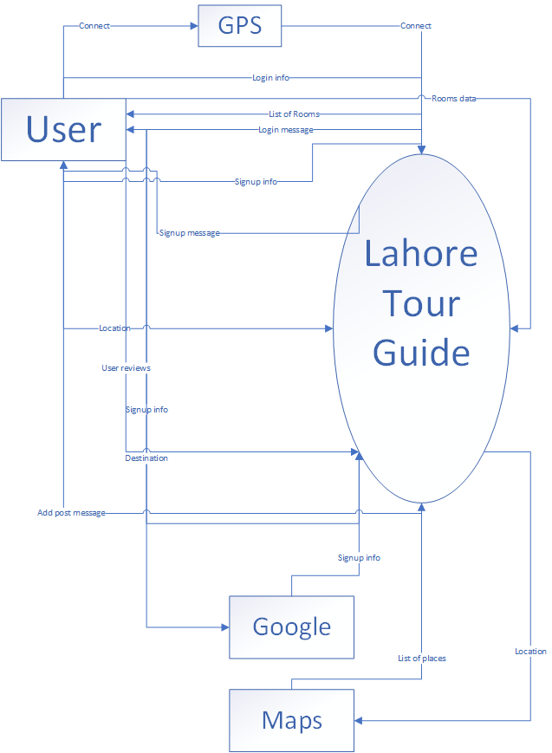

1.8.8 Capture "shall" Statements and the external entities (Actors)
Identify “shall” statements, as they would be all functional requirements.
No | Entities | Initial Requirements
1 | User | Shall download app from store
2 | User | Shall create account for app
 | User | The user “shall” sign in to the application.
3 | User | Shall allow their location to be accessed
4 | User | Shall choose an option (destinations, nearby, hotels and restaurants, rental apartments)
5 | User | Shall choose destinations option
6 | User | Shall choose categories from the list
7 | User | Shall select the location from the list
8 | System | Shall provide details and directions of the selected location
9 | User | Shall select restaurant or hotel option
10 | System | Shall provide details or directions of restaurant and hotel
11 | User | Shall select rental apartment option
12 | System | Shall provide list of available rental rooms
13 | User | Shall select a room or apartment from the list
14 | System | Shall provide details or directions of room or apartment
15 | User | Shall request to post an add for room or apartment
16 | User | Shall provide information about the add
17 | System | Shall add the details to the database
18 | User | Shall start a conversation with the owner of the room or apartment
19 | User | Shall add reviews for the room or apartment

1.8.9 Allocate Requirements
No | Initial Requirements | Use Case Name
1 | User Shall create account for app | UC_Register
2 | User Shall login to account | UC_Login
3 | User Shall connect GPRS | UC_Connectivity
4 | User Shall choose destination | UC_ Search_Place
5 | User Shall see details and contact | UC_Details
6 | System shall provide location directions | UC_Get_Directions
7 | User Shall upload/update/delete reviews | UC_Review_Activity
8 | User shall select rental room option/ landlords can add their advertisement | UC_Rental_Ads
9 | User shall chat with landlords | UC_Conversation
10 | Landlord should manage their advertisement | UC_Ads_Management
11 | System Shall communicate with central database to authenticate and manage data | UC_System_Communication
12 | System Shall delete advertisements on basis of reviews | UC_System_Control

1.8.10 Priorities Requirements
No | Rank | Initial Requirements | Use Case Id | Use Case Name
1 | High | User Shall create account for app | UC_1 | UC_Register
2 | High | User shall login to account | UC_2 | UC_Login
3 | medium | User Shall choose destination | UC_4 | UC_Search Place
4 | Low | User Shall add/delete reviews | UC_7 | UC_Review_Activity
5 | High | User Shall connect with internet/GPRS | UC_3 | UC_Connectivity
6 | medium | Landlord shall manage ads | UC_10 | UC_Ads_Management
7 | medium | Landlord Shall upload/update/delete its advertisement | UC_8 | UC_Rental_Ads
8 | High | System shall provide location directions | UC_6 | UC_Get_Directions
9 | medium | User shall see details | UC_5 | UC_ Details
10 | Low | System Shall provide chat option | UC_9 | UC_Conversations
11 | medium | System Shall communicate with central database to authenticate and manage data | UC_11 | UC_System_Communication
12 | Low | System Shall delete advertisements automatically on basis of reviews | UC_12 | UC_System_Control

1.8.12 Requirements Traceability Matrix
No | Build | Initial Requirements | Category | Use Case Name
1 | B1 | User Shall create account for app | Functional | UC_Register
2 | B1 | User Shall login account for app | Functional | UC_Login
3 | B1 | User Shall connect with internet/GPRS | Functional | UC_Connectivity
4 | B1 | System shall provide location directions | Functional | UC_Get_Directions
5 | B2 | User Shall choose destination | Functional | UC_Search_Place
6 | B2 | Landlord Shall upload/ delete its advertisement | Business | UC_Rental_Ads
7 | B2 | Landlord shall manage ads | Business | UC_Manage_Ads
8 | B2 | User shall see details | Functional | UC_Details
9 | B2 | System Shall communicate with central database to authenticate and manage data | Functional | UC_ System_Communication
10 | B3 | User Shall add/delete reviews | Business | UC_Review_Activity
11 | B3 | System Shall provide chat option | Functional | UC_Converstaions
12 | B3 | System Shall delete advertisements automatically on basis of reviews | Business | UC_System_Control
13 | B3 | System Shall notify the user to activate his GPRS for the starting of app | Functional | UC_System_Notification

1.9 High Level Usecase Diagram
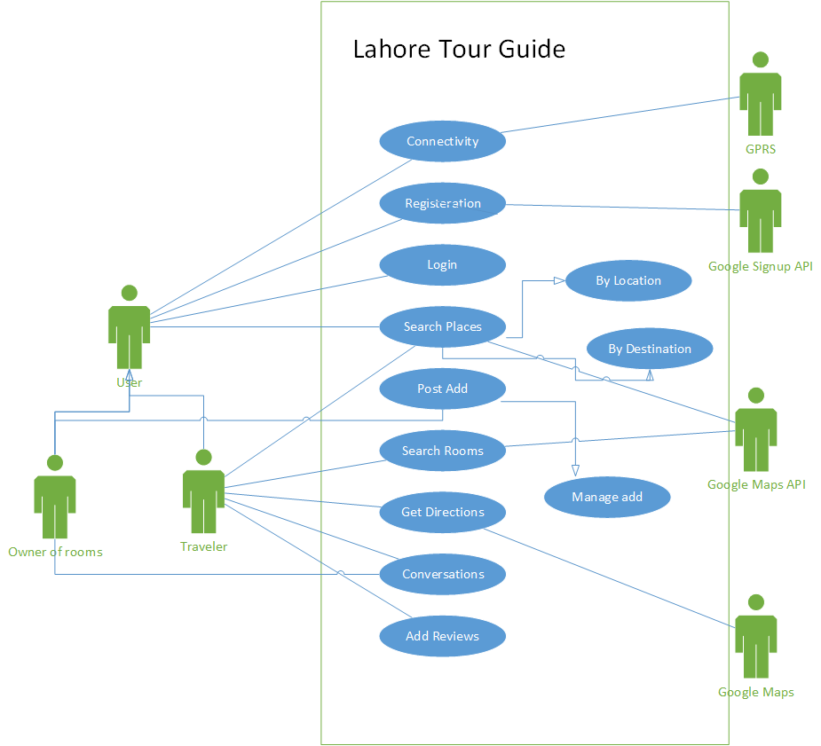

1.9 Risk List
Following are the risks in the development of the proposed application.

1.9.1 Risk related to the Requirement Engineering
- The rate of change of requirement is unpredictable.
- The change in requirements changes the scope of the application.

Risk related to the Scope Management
- The scope of the project is not clearly understood by any of the project management office, supervisory staff or developing team.
- The scope of the project is scattered due to the dropped requirements or the requirement change.
- The scope of the product mention in the proposal is not attainable in normal circumstances.

1.9.3 Risk related to the team
- Supervisory staff is either not available or is unable to render the facility on any basis.
- The scope of the project moves out from the specialization of the supervisor.
- The resource person in the team is not available due to any reason.
- Lack of team Management Corporation can be a high risk.

1.9.4 Risk related to the System
- Estimated size may varies from actual size.
- Security risk.
- Tools & requirements are incompatible.
- Development tools do not provide planned productivity.

1.9.5 Risk related to the Estimation
- The time required to develop the software is underestimated.
- Cost estimated is low.

